English Vocabulary: ‘keep’ vs ‘maintain’

The verbs keep and maintain are often synonymous, however keep is more informal and much more common in everyday conversations.

a) to keep (usually transitive) (keep / kept / kept) (informal)

1. store in a place I keep my car in the garage.
I keep cash in my wallet.
2. make somebody wait My wife always keeps me waiting when we go out.
3. stay with Please keep the change.
We have decided to keep our car.
4. continue I think that you should keep studying English.
I always keep myself updated.
I try to keep my plants alive.
Keep calm and carry on!
You must keep him awake until his operation.
5. prevent Please keep your dog from coming into the house.
6. detain My parents kept me in my bedroom all weekend!
John keeps his dog in the kitchen when he has visitors.
What kept you in London for so long?
7. retain Can you keep a secret?
8. fulfill I always keep a promise. I never break a promise.
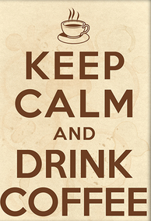
9. withhold information She kept the news from me for a week.
Please keep your opinion to yourself.
10. register We keep records of all transactions.
11. have We keep a beach house in Miami.
12. stay It’s important to keep healthy.
I always keep myself in good shape.

Limits
1. keep above I can’t keep my head above the water! Help me!
2. keep below I try to keep my credit card spends below $1000.
3. keep under You must keep the black box under the water.
4. keep behind Please keep behind the line.
5. keep to the left/right Please keep your car to the left. We’re in England now!

Phrasal verbs

1. keep at (+ noun) continue You should keep at English.
2. keep on (+ verb) continue You should keep on studying English.
3. keep back contain I can’t keep the tears back.
The police can’t keep the crowd back.
4. keep down control You can’t keep down the rebels for long.
I feel sick. I can’t keep my food down.
5. keep off avoid Please keep off the grass.
Please keep the cat off the table.
6. keep out of don’t enter Please keep out of the kitchen.
don’t put in Please keep the honey out of the fridge.
7. keep to follow/respect Please keep to your lane on the highway.
You must keep to the rules of the game.
8. keep up with go at same speed I can’t keep up with John – he runs so fast.
I can’t keep up with Bob – he studies all the time.
9. keep away stay far Keep away from the edge of the cliff.
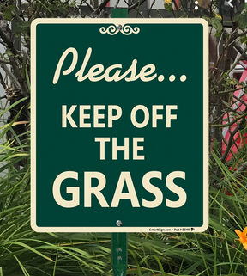
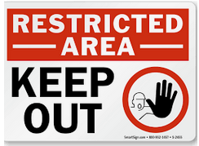

Other vocabulary/expressions

keep your distance stay far Please keep your distance from the car in front.
for keeps worth a lot Your boyfriend is wonderful – he is for keeps!
keeper guard Bob is an excellent zoo keeper.
keep-fit exercise place Let’s go to keep-fit tomorrow.
in keeping with in a similar way Let’s decorate the kitchen in keeping with the 1950s.
goalkeeper defender of goal England’s goalkeeper is fantastic!
zookeeper worker at zoo When I grow up I want to be a zookeeper.
keep your hair on stay calm Keep your hair on! Don’t go crazy!
keepsake * souvenir This locket is a keepsake. It was my mother’s.

* Keepsake is a synonym of souvenir. However, the difference is that keepsake is an object given by a person and it is kept in memory of that person, for sentimental or nostalgic reasons, while souvenir is an item of sentimental value which is kept to remember an event or location.

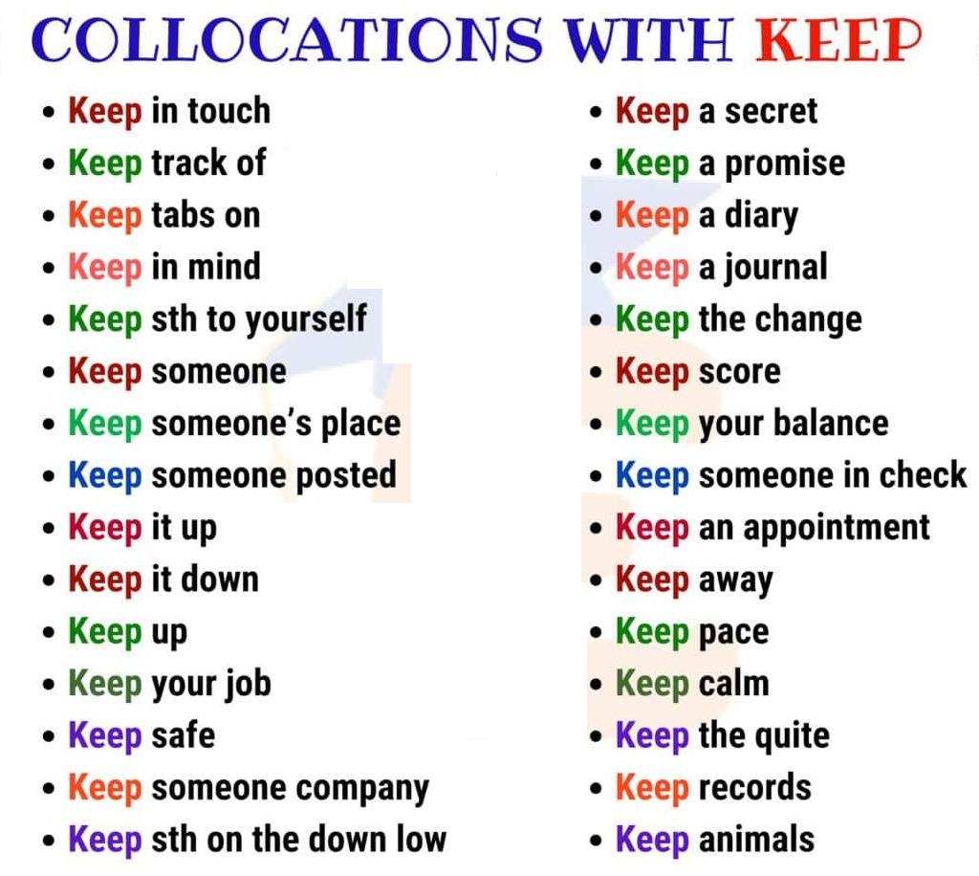

Source: www.englishstudyonline.org

b) to maintain (regular verb) (formal)

1. provide for It is not easy to maintain a large family.
2. take care of My job is to maintain all the equipment in the factory.
My house is very well maintained.
3. assert I maintain that my decision was correct.
4. not lose It’s important to maintain your principles.
5. not change I maintain my opinion.
6. do maintenance It’s expensive to maintain many properties.

Hint:
When you want to say “manter” in Portuguese, use the verb “keep” in English, and you will be correct 99% of the time! “Maintain” is usually used only for formal situations.

